
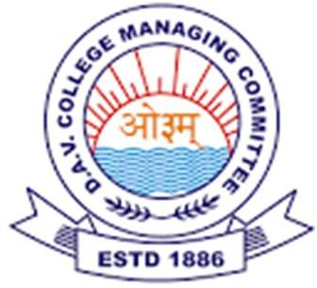
DAV HZL SR SEC SCHOOL ZAWAR MINES UDAIPUR
A Unit of DAV College Managing Committee New Delhi CBSE Affiliation No 1730723

Syllabus for session 2025-26

Class -VI

Subject | PT- I | TERM- I | PT- II | TERM- II
हिंदी | 1 साथी हाथ बढाना  2 चिट्ठी के अक्षर  3 बरसते जल के रुप अनेक  4 पुरस्कार  5 सीखों | 1 साथी हाथ बढाना  2 चिट्ठी के अक्षर  3 बरसते जल के रुप अनेक  4 पुरस्कार  5 सीखों  6 अनोखा वरदान  7 सुंदर लाल  8 नजानू कवि बना  9 वोहे  10 पोंगल  अपठित गद्यांश,काव्यांश | 11 तेनालीराम ने चारों को.........  12 दस आमों की कीमत  13 अनोखी दौड  14 एक रोमांचक यात्रा  15 परिश्रम  16 धान की खेती | (11) तेनालीराम ने चारों को.........  (12) दस आमों की कीमत  (13) अनोखी दौड  (14) एक रोमांचक यात्रा  (15) परिःञम  (16) धान की खेती  (17) यात्रा और यात्री  (18) पंच परमेश्वर  (19) सिकंदर और साधु  (20) आया वसंत  (6) अनोखा वरदान (20 प्रतिशत पाठ्यक्रम आवथिक परीक्षा)  (9) दोहे (20 प्रतिशत पाठ्यक्रम आवथिक परीक्षा)
English | English Literature:  Lesson- 1 How Daddy  decided what he wanted to be? | English Literature:  Lesson- 1 How Daddy Decided | English Literature:  Lesson- 7 Bharat Desh | English Literature
 | Lesson-2 The White Elephant | What He Wanted to Be?  Lesson- 2 The White Elephant  Lesson- 3 Leisure  Lesson- 4 My Experiments with | Lesson-8 Hanuman and I  English Reader:  Unit-4 Performing Arts | Lesson-7 Bharat Desh  Lesson- 8 Hanuman and I  Lesson- 9 Our Tree  Lesson-10 Attila  Lesson- 11 The Case of Copied Question Papers
 | English Reader:  Unit- 1 Celebrations  English Practice:  Lesson- 1 Putting  It Together  Notice Writing,  Informal Letter | Truth  Lesson- 5 Today and Tomorrow  Lesson-6 The Helpful Young Man  English Reader:  Unit-1 Celebrations  Unit- 2 Hobbies  Unit- 3 Thrill in School Life | English Practice:  Lesson- 7 Tenses (Part-III) Perfect Tenses  Lesson-8 Modals  E-mail, | English Reader:  Unit-4 Performing Arts  Unit- 5 Vacation Time  Unit-6 Tinsel World
 |  | English Practice:  Lesson- 1 Putting It Together  Lesson- 2 Regular and Irregular |  | English Practice:  Lesson- 6 Tenses (Part-II) Continuous Tenses  Lesson 7 Tenses ( Part-III) Perfect Tense
 |  | Verbs  Lesson- 3 Determiners  Lesson-4 Subject Verb Agreement  Lesson 5 Tenses (Part-I) Simple Tenses  Unseen Passage  Notice, Informal Letter, Speech |  | Lesson-8 Modals  Lesson- 9 Conditionals  Lesson-10 Passive Voice  Lesson- 11 Reading for Understanding, Speech,Email, informal Letter  20% Syllabus Mid Term Assessment  English Literature  Lesson- 6 The Helpful Young Man  English Practice  Lesson-5 Tenses ( Part-1) Simple Present Tense

Mathematics | Ch-1 Natural Numbers Ch-8 Basic Geometrical Shapes | Ch-1 Natural Numbers  Ch-2 Factors andMultiples  Ch-3 Integers  Ch-4 Ratio,Proportional Unitary Method  Ch-8 Basic Geometrical Shapes  Ch-9 Line Segments  Ch-10 Angles | Ch-11 Transversal and Pair of Lines  Ch-12 Triangles | Ch-5 Percentage and It applications Ch-Ch-6 Introduction to Algebra  Ch-7 Linear Equation  Ch-11 Transversal and Pair of Lines  Ch-12 Triangles  Ch-13 Circles  Ch-14 Construction  Ch-15 Perimeter and Area  Ch-16 Statistics
20% Syllabus from Mid Term Assessment
Ch-2 Factors and Multiples
Ch-3 Integers
Science | Ch.1-Our Environment  Ch.2- Food | Ch. 1- our environment Ch.2 -Food  Ch.3- Nature of Matter  Ch.4- separation of substances Ch.5- Changes around us  Ch.6- Measurement and Motions | Ch.7- The World of Living  Ch.8- Structure and function of living organisms plants  Ch.9- Structure and function of living organisms animals | Ch.7-The World of Living  Ch.8- Structure and functions of living organisms plants  Ch.9-Structure and functions of living organisms  Ch.10-Work and Energy  Ch.11- Electric currents and circuits.
Ch.12- Light and Shadows
Ch.13- Magnets
 |  |  |  | Ch.14- Fabric and fibres
 |  |  |  | 20% Syllabus from Mid Term Assessment
 |  |  |  | Ch.5- Changes around us

Social Science GEOGRAPHY | CHAPTER-1  The Planet Earth and the Solar System  CHAPTER-2  Representation of the Earth | CHAPTER-1  The Planet Earth and the Solar System  CHAPTER-2Representation of the Earth  CHAPTER-3Locating Places on the Earth  CHAPTER-4The Motions of the Earth | CHAPTER-6 India-My  Motherland | CHAPTER-5The Realms of the Earth  CHAPTER 6India-My Motherland CHAPTER-7India-The Land of Monsoon Climate
HISTORY | CHAPTER 8-Studying the Past  CHAPTER 9-Lifeof Early Man | CHAPTER 8-Studying the Past CHAPTER 9Life of Early Man CHAPTER 10-Development of Civilisation  CHAPTER 11-The Iron Age Civilisation  CHAPTER 12-Janapadas and the Mahajanapadas  CHAPTER 13-TheMauryan Dynasty | CHAPTER 14-  Early History of Deccan and South India  CHAPTER 15-North  India after Mauryas and  Sungas | CHAPTER 14-Early history of Deccan and South India  CHAPTER 15-NorthIndia after Mauryas CHAPTER 16-The Gupta Empire  CHAPTER 17-TheEra of Harsha  CHAPTER 18 -Deccan and South  India  CHAPTER 19- India and the Outside World  CHAPTER 20-The Indian Religions
CIVICS | CHAPTER-21 Our Community life: Unity in Diversity | CHAPTER 21-OurCommunity Life: Unity in Diversity  CHAPTER 22-Democracy and Government | CHAPTER 23-OurRural Governance | CHAPTER 23-OurRural Governance CHAPTER 24-OurUrban Government  20% Syllabus from Mid Term Assessment CHAPTER 21-OurCommunity Life: Unity in Diversity  CHAPTER 22-Democracy and Government
संस्कृत | 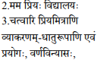 | 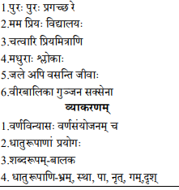  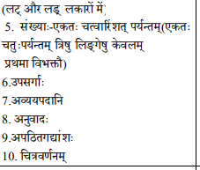 | 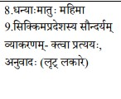 | 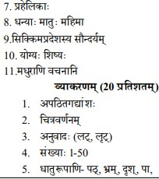  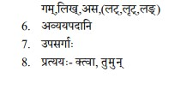
ICT | Ch : =1-4 |  | Ch : 5-8
G.K. | Page 1-45 |  | Page 46-91
Moral Education | Ch.1 to 6 |  | Ch.7 to 13
Drawing | Drawing Book- 1-21 |  | Drawing Book 21-40

Class Teacher Academic Coordinator Principal

